Name: Son Tran

Professor Paul Bladek

CS 131

January 21st , 2017

**Test Plan for Project 1**

|  |  |  |  |  |  |
| --- | --- | --- | --- | --- | --- |
| **No** | **Purchase Input** | **Expected Purchase Output** | **Actual Purchase Output** | **Reason for Test** | **Reason for Difference** |
| **1** | **15.3456** | **15.35** | **15.35** | **Small Rounding** | **n/a** |
| **2** | **1945647.246** | **1945647.25** | **1945647.25** | **Big Rounding** | **n/a** |
| **3** | **-254.32** | **-254.32** | **-254.32** | **Negative number** | **n/a** |
| **4** | **I am Son Tran** | **asking to enter again until input is correct** | **prompt to ask for input again** | **Non-numeric** | **n/a** |
| **5** | **381900000** | **381900000.00** | **381900000.00** | **GDP problem** | **n/a** |

Data for money purchase input:

Data for money tender input:

|  |  |  |  |  |  |
| --- | --- | --- | --- | --- | --- |
| **No** | **Money Tendered Input** | **Expected Money Tendered Output** | **Actual Money Tendered Output** | **Reason for Test** | **Reason for Difference** |
| **1** | **24.3569** | **24.36** | **24.36** | **Small rounding** | **n/a** |
| **2** | **3651784.339** | **3651784.34** | **3651784.34** | **Large rounding** | **n/a** |
| **3** | **-365.17** | **-365.17** | **-365.17** | **Negative number** | **n/a** |
| **4** | **surprise** | **asking to enter again until input is correct** | **prompt to ask for input again** | **Non-numeric** | **n/a** |
| **5** | **17914000000000** | **17914000000000.00** | **17914000000000.00** | **GDP problem** | **n/a** |

Chang Amount output

|  |  |  |  |  |  |  |
| --- | --- | --- | --- | --- | --- | --- |
| **No** | **Purchase Input** | **Money Tendered Input** | **Expected Change Output** | **Actual** | **Reason for Test** | **Reason for Difference** |
| **Change Output** |
| **1** | **15.35** | **24.36** | **9.01** | **9.01** | **small number Calculation** | **n/a** |
| **2** | **1945647.25** | **3651784.34** | **1706137.09** | **1706137.09** | **big number Calculation** | **n/a** |
| **3** | **-254.32** | **-365.17** | **-110.85** | **-110.85** | **Owing money and negative number** | **Just different at owing money** |
| **4** | **I am Son Tran enter again 15** | **surprise enter again 69** | **54** | **54** | **test if program work after enter input again** | **n/a** |
| **5** | **381900000.00** | **17914000000000.00** | **17913618100000.00** | **17913618100000.00** | **GDP problem** | **n/a** |

Expected Output for amount of Bills

|  |  |  |  |  |  |  |  |  |  |  |
| --- | --- | --- | --- | --- | --- | --- | --- | --- | --- | --- |
| **No** | **Amount of Change** | **Twenties** | **Tens** | **Fives** | **Ones** | **Quarters** | **Dimes** | **Nickels** | **Pennies** | **Reason for Test** |
| **1** | **9.01** | **0** | **0** | **1** | **4** | **0** | **0** | **0** | **1** | **small number calculation** |
| **2** | **1706137.09** | **85306** | **1** | **1** | **2** | **0** | **0** | **1** | **4** | **big number calculation** |
| **3** | **-110.85** | **5** | **1** | **0** | **0** | **3** | **1** | **0** | **0** | **Negative number leads to owing** |
| **4** | **program work after enter input again Amount of change after: 54** | **5** | **1** | **0** | **0** | **3** | **1** | **0** | **0** | **Non numeric number** |
| **5** | **17913618100000.00** | **895680905000** | **0** | **0** | **0** | **0** | **0** | **0** | **0** | **GDP Problem** |

Actual Amount out Bills output

|  |  |  |  |  |  |  |  |  |  |  |  |
| --- | --- | --- | --- | --- | --- | --- | --- | --- | --- | --- | --- |
| **No** | **Amount of Change** | **Twenties** | **Tens** | **Fives** | **Ones** | **Quarters** | **Dimes** | **Nickels** | **Pennies** | **Reason for Test** | **Reason of Difference** |
| **1** | **9.01** | **0** | **0** | **1** | **4** | **0** | **0** | **0** | **1** | **small number calculation** | **n/a** |
| **2** | **1706137.09** | **85306** | **1** | **1** | **2** | **0** | **0** | **1** | **4** | **big number calculation** | **n/a** |
| **3** | **-110.85** | **5** | **1** | **0** | **0** | **3** | **1** | **0** | **0** | **Negative number leads to owing** | **n/a** |
| **4** | **program work after enter input again Amount of change after: 54** | **5** | **1** | **0** | **0** | **3** | **1** | **0** | **0** | **Non numeric number** | **n/a** |
| **5** | **17913618100000.00** | **895680905000** | **0** | **0** | **0** | **0** | **0** | **0** | **0** | **GDP Problem** | **n/a** |

**Picture of Sample test run**

Total purchase: 15.3456

Amount of money tendered: 24.3569

Amount of change output: 9.01

Twenties: 0

Tens: 0

Fives: 1

Ones: 4

Quarters: 0

Dimes: 0

Nickels: 0

Penny: 1

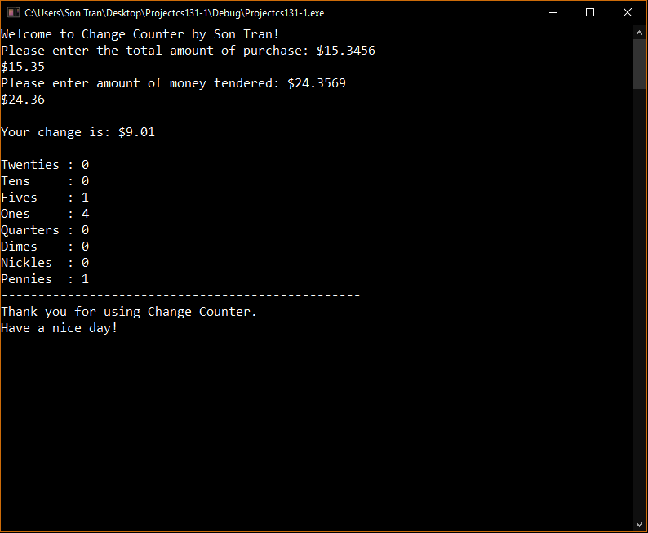

Total purchase: 381900000.00

Amount of money tendered: 17914000000000.00

Amount of change output: 17913618100000

Twenties: 895680905000

Tens: 0

Fives: 0

Ones: 0

Quarters: 0

Dimes: 0

Nickels: 0

Penny: 0

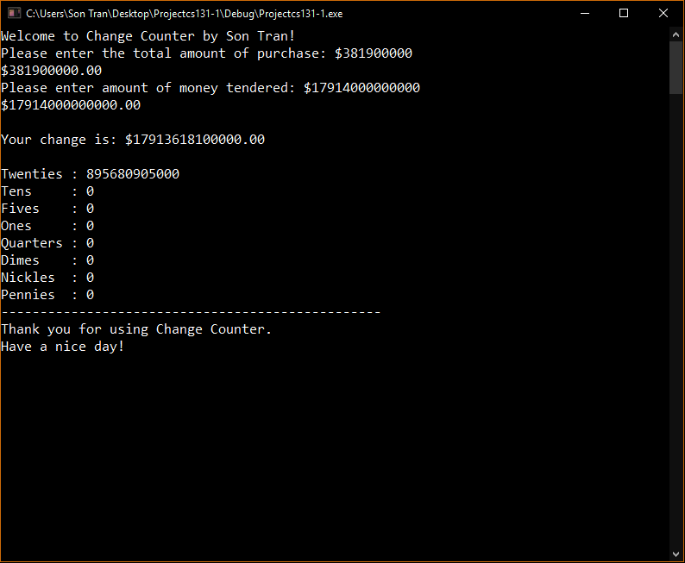

Total purchase: -254.32

Amount of money tendered: -365.17

Amount of change output: -110.85

Twenties: 5

Tens: 1

Fives: 0

Ones: 0

Quarters: 3

Dimes: 1

Nickels: 0

Penny: 0

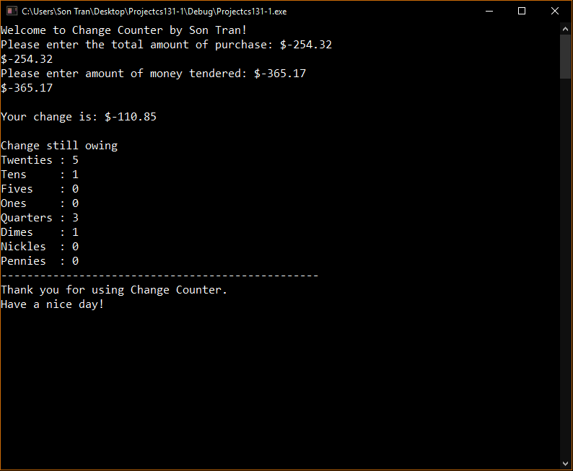

Total purchase: I am Son Tran

Amount of money tendered: Surprise

Amount of change output: Asking to input again until program get a suitable data

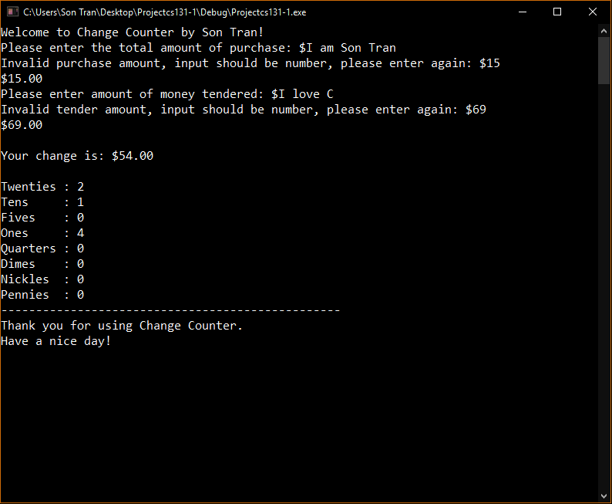

**Problem with my Program**

My program has problem to deal with a very very huge input number. I know that this problem is caused because the variable I used does not have enough memory to hold a very big number. The biggest amount of money that can be hold in the variable is 3.4E-4932 to 1.1E+4932 so if I put the number bigger than 19 decimals places the program will assign some magic numbers when it does the calculation. I am trying to find the way to fix the problem but for money I only know the biggest data variable is long double and that is all I can do to extend the range of money. But I think 19 decimal places is enough for this program.